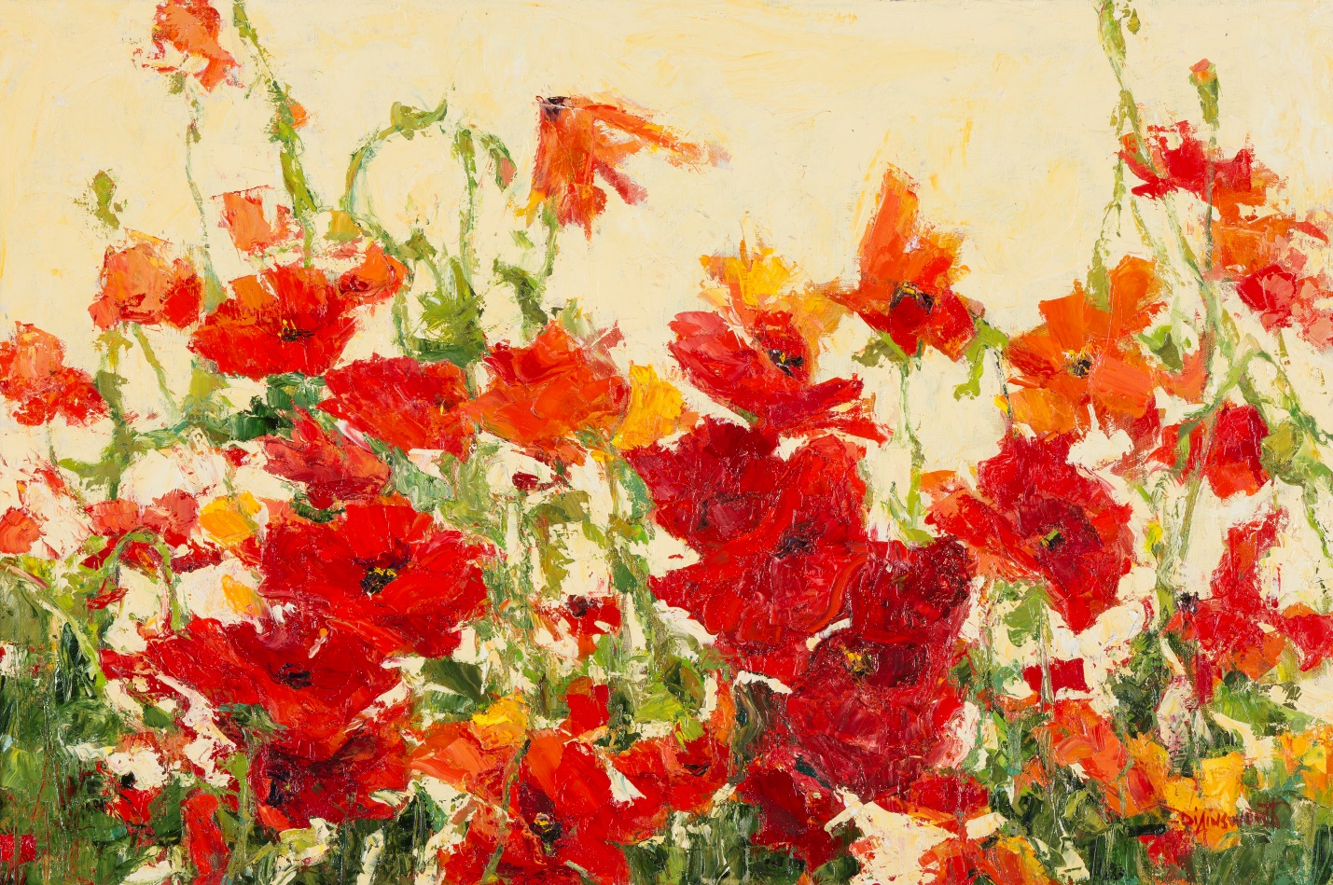

Vision of Impressionism:

Paintings from the Oklahoma Society of Impressionists

EDUCATORS RESOURCE

# Exhibition Details

## About the exhibition

The Oklahoma Society of Impressionists (OSI) began in 1987 when a group of artists met in Taos, New Mexico, at a plein air workshop. The group was formed to represent and support Oklahoma artists painting in the impressionist style, to raise public appreciation for plein air, and to promote excellence in representational art.

OSI has exhibited across the state of Oklahoma as well as in Texas, Colorado, Missouri, and Arkansas. The membership of OSI is limited to artists who must have Oklahoma roots and/or live in Oklahoma. Vision of Impressionism showcases highlights of recent works by artists from OSI.

This exhibition is organized by the OSU Museum of Art and curated by James W. Bruce, Jr. and Linda Howell.

## Exhibition dates, events, and related programs

June 20, 2016 – August 6, 2016

Reception + drawingLAB: Thursday, June 30th, 5:00-7:00 PM

This drawingLAB is held in conjunction with the Vision of Impressionism opening reception. This unique, merged event provides participants with a chance to meet and interact with the artists who will be in attendance. DrawingLAB is welcoming to visitors of all ages and abilities. All you need is paper, pencil, and an open mind!

Family Day: Saturday, June 9th, 11:00 AM – 3:00 PM

drawingLAB: Thursday, July 28th, 6:00 PM at The Botanic Garden

Join us at the beautiful OSU Botanic Garden for an evening of *en plein air* drawing. Explore techniques for observing and capturing the world around you with artists featured in *Vision of Impressionism*, on view at the OSU Museum of Art through August 6. This event is free and open to the public. All you need is paper, pencil, and an open mind.

## About the curator(s)

This exhibition is curated by James W. Bruce, Jr. and Linda Howell.

# Class Visits and Tours

The exhibition is suitable for all ages.

## Curricular connections

Painting/drawing technique (Impressionism)

## Booking a tour/visit – “Beyond the Classroom”

*Beyond the Classroom* (the OSU Museum of Art’s PK-12 inquiry based tour program) encourages students of all abilities to engage with art and each other by looking deeply, and thinking creatively and critically. Students make personal and curricular connections through discussion, writing, and hands-on activities. We welcome both public school groups and home-schoolers. Admission to the museum is always free.

To book a tour, please visit <http://museum.okstate.edu/tours>. Please be advised that we require at least three weeks advanced notice for tours of 10 or more to allow for appropriate staffing.

For more information, to discuss programming, or to request a transportation or substitute teacher subsidy, please contact Carrie Kim, Curator of Education and Programming, at (405)744-2785 or [carrie.kim@okstate.edu](mailto:carrie.kim@okstate.edu).

# Online Resources

Follow the OSU Museum of Art Pinterest page at <https://www.pinterest.com/osumuseumofart/> to stay up-to-date on all educator resources, news articles, curatorial talks, artist talks, artist presentations, and more.

Oklahoma Society of Impressionists

<http://www.okhistory.org/historycenter/impressionists>

Art and Man, American Impressionists featuring Mary Cassatt, Scholastic

A magazine featuring articles introducing impressionism, the life and work of Mary Cassatt, a poster of “The Bath” by Mary Cassatt, a focus on three modern Impressionist artists, and a lesson on creating dynamic compositions.

<https://museum.okstate.edu/sites/default/files/Art%20and%20Man%20Scholastic.pdf>

# Discussion Questions

Pose the following questions to your students.

# Impressionism